No matter what your chosen topic is, you will always be able to create a timeline. If you are focusing on a time period you can timeline important events, if you are researching a famous person you can plot key points in their life. If you are finding out about an event your timeline could be for a single day. The important things to remember are: to keep it in chronological order, try and space out events to show the length of time between and try and give as much detail as possible.

How to present a timeline
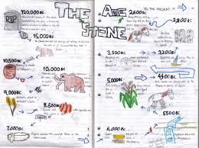
A timeline doesn’t have to be a straight line. You can use a combination of images and texts to present your information to the reader
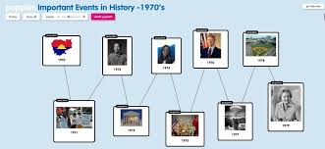
You could use an app or a computer – Popplet is a free app that you can use to show a sequence of events

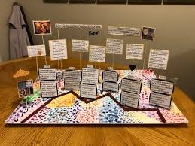
You could make a 3D timeline to make your topic come to life!

