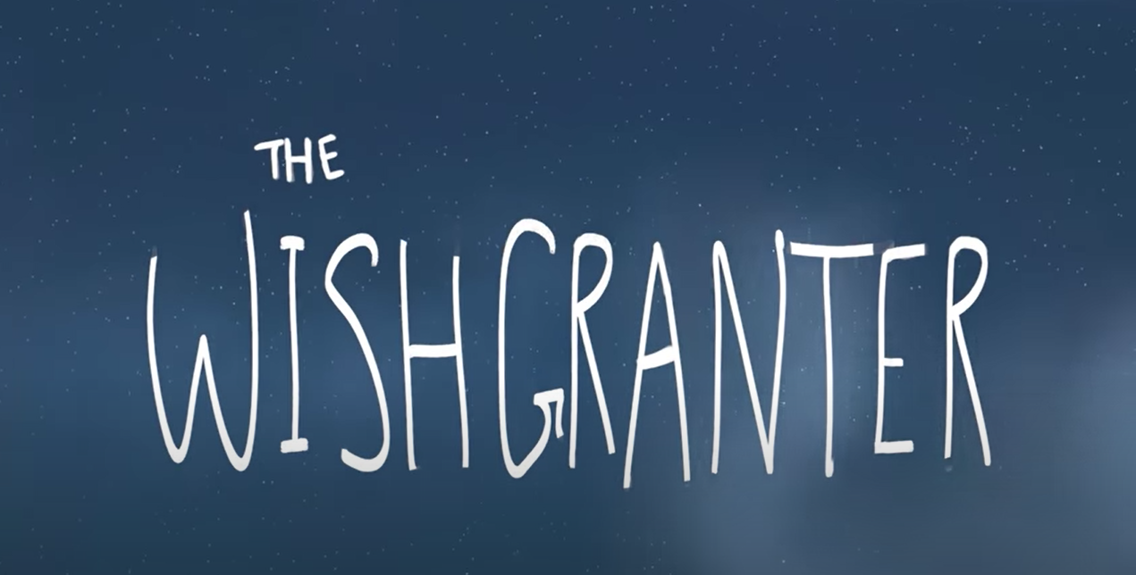
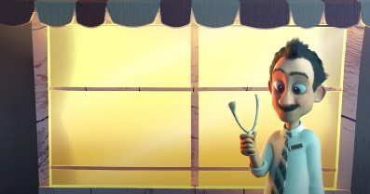
Here are some screenshots from a short film (please don’t watch the film until later in the week. The pictures are not in order. Look at the images and try and work out what the story could be. The story is called The Wishgranter – Does this help you make up the story. Make some notes about what you think the story could be thinking about each picture. As you can see there are 4 characters, make sure they are all included in your prediction of the story.

__________________________________________________________________________________________________________________________________________________________________________________________________________________________________________________________________________________________________________________________________________________________________________________________________________________________________________________________________________________________________________________________________________________________________________________________________________________________________________________________________________________________________________________________________________________________________________________________________________________________________________________________________________________________________________________________________________________________________________________________________________________________________________________________________________________________________________________________________________________________________________________________________________________________________________________________________________________________________________________________________________________________________________________________________________________________________________________________________________________________________________________________________________________________________________________________________________________________________________________________________________________________________________________________________________________________________________________________________________________________________________________________________________________________________________________________________________________________________________________________________________________________________________________________________________________________________________________________________
