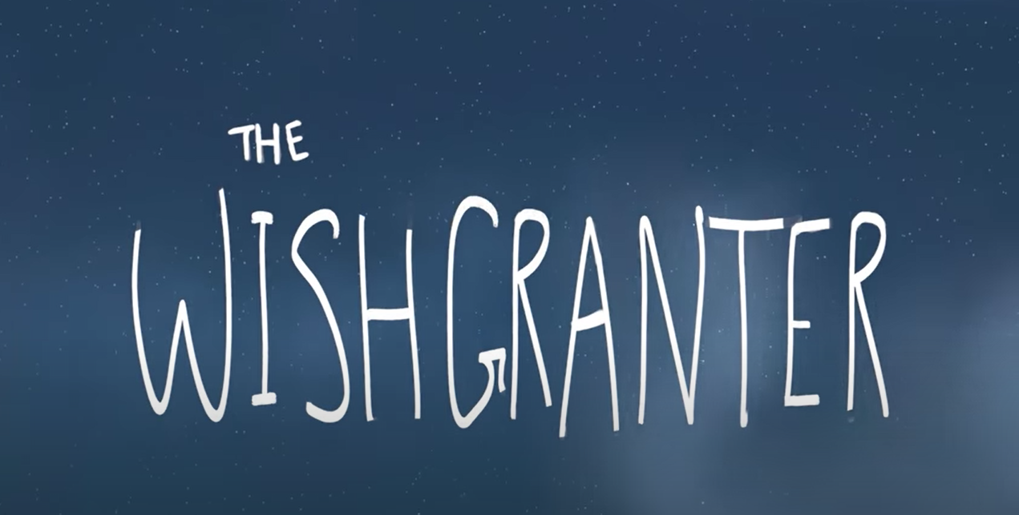

Hopefully from the title and the images you have realised this short film is about making wishes. (Please don’t watch the film yet!) Today we are going to do some research about making wishes and then make our own wish jar.
Before having a look at this links about when people make wishes, can you think of times when you have seen people making a wish?
Now have a look at the links to read about when some people think it is best to make a wish.
https://www.factmonster.com/features/speaking-language/making-wishes
https://www.puckermob.com/fun/make-a-wish-21-things-you-can-wish-on-directions-included/
Now we are going to make our own wish jar. Here are some instructions. If you don’t have the materials, I have also included a jar outline where you can just write in your wishes. These instructions are for a Things to look forward to jar – but it is the same process.
