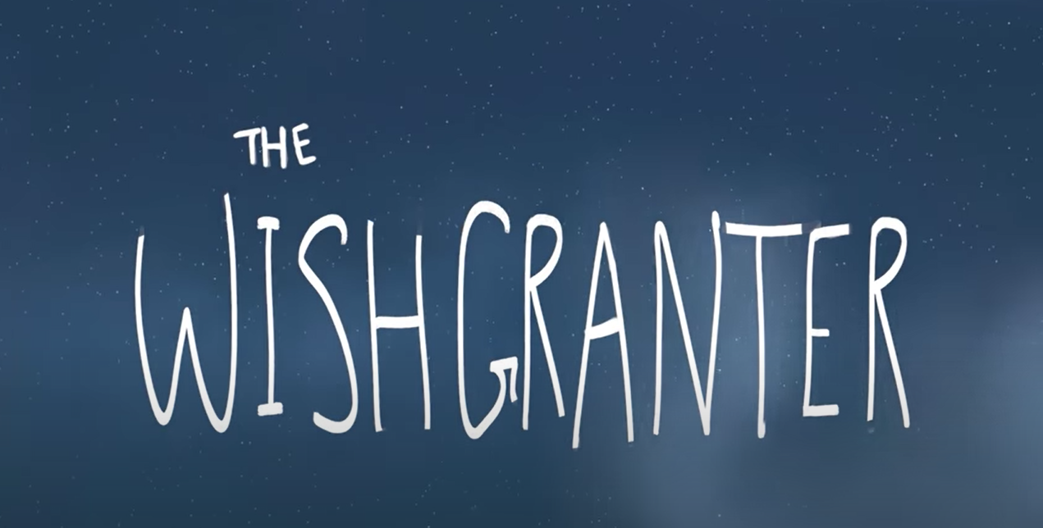

The children at school don’t have a lesson today as they are in the forest. You can have a day off literacy/ spend some more time reading/ practice your spellings / practice your handwriting. I have given you a word challenge to keep you busy

Word challenge – Our work is about wishes

Can you find synonyms for these words?

Wish

Wishes (because whish ends in a h you have to add es – can you think of any other words where you have to add es?)

Wishing

When you have found some synonyms can you rank them from the weakest to the strongest?

