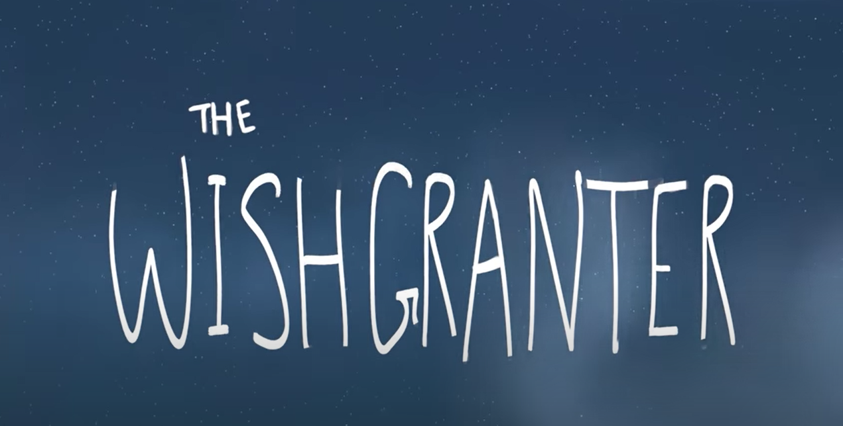

Today you can watch the film!
https://www.youtube.com/watch?v=zON0wDD7VJY
Was the story as you expected? How close was your prediction?
Today your task is to try and answer these questions based on the video. The red questions are the harder questions and the green questions are easier. If you are in year 4 and some of year 5 you may only want to do the green questions. If you are in year 5 or 6 you need to try the red.
What did first the man wish for?
__________________________________________________________________________________________________________________________________
What did the man and lady wish for?
__________________________________________________________________________________________________________________________________
What happens to the coins when they are thrown in the fountain? Explain
___________________________________________________________________________________________________________________________________________________________________________________________________
How does the Wishgranter grant the wish?
__________________________________________________________________________________________________________________________________
What happened when the coins got stuck?
___________________________________________________________________________________________________________________________________________________________________________________________________
What was in the Wishgranter’s emergency case? Why were these things in there?
___________________________________________________________________________________________________________________________________________________________________________________________________
Did the Wishgranter’s emergency kit work? Explain
____________________________________________________________________________________________________________________________________________________________________________________________________________________________________________________________________
Why do you think the Wishgranter kept trying to grant the man and lady’s wish?
___________________________________________________________________________________________________________________________________________________________________________________________________
How did the Wishgranter feel at the end?
__________________________________________________________________________________________________________________________________
Do you think the Wishgranter cares about the people making wishes? Explain using evidence from the text.
___________________________________________________________________________________________________________________________________________________________________________________________________
Do you think wishes can come true?
____________________________________________________________________________________________________________________________________________________________________________________________________________________________________________________________________
Next week we are going to start looking at writing the Wishmaker story.

