This week we are going to write the story of The Wishgranter. You don’t have to stick to every detail in story you can add your own details and leave parts out. Everyday I will give you a part of the story to focus on so you may want to rewatch that part. Then I will give you two writing targets to try and include in your writing. I will give you two activitities to practice the targets before you try and do your writing. I hope that makes sense!
Today we are looking at part 1 0.08 seconds – 0.37 seconds make a wish time.
Your writing targets today are:
To add a relative clause (starting with who)
To include a list punctuated correctly with commas

Lets start with target 1
Here is a sentence
Tom Daley is a diver, who won a bronze medal at the London Olympics.
,who won a bronze medal at the London Olympics is your relative clasue. Tom Daley is a diver is your main clause.
Can you add a relative clause to these sentences. Remember the relative clause tells us a little bit of extra information about the subject of the sentence (could be age, where they live, interesting fact …)
Roald Dahl, who ________________________________, wrote Matilda.
My teacher, who ____________________________________________, says I work hard.
Queen Elizabeth, who _________________________________________, has four children.

Target 2
We should all know how to use commas correctly in a list. We use a comma between each item except the last two where we would use and.
Correct these sentences
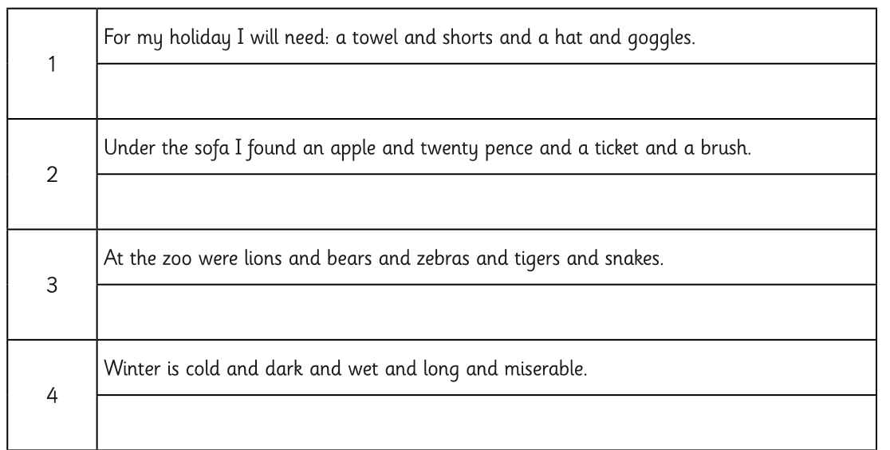

Writing time
Here is a WAGOLL for this part of the story – can you see my list and relative clause?
The sky was an inky black with white dots everywhere. In the centre of the square stood a tall elegant fountain, where many people had wished for their heart’s desires. After removing a coin from his otherwise empty pockets, a man kissed it and flicked it into the fountain. The coin sank leisurely before rolling into a wide tube, then falling onto the spinning wheel, at that moment it landed on a floating bucket as it soared into the air and crashed into yet another pipe. Before long, it crashed onto a pile of other gold coins that shone radiantly in the light as a man, who seemed bored by what he was doing, sat on a chair with an enormous screen in front of him.

Now you have a try remember you need a relative clause starting who and a list. It only needs to be a few sentences long, but make them interesting!

__________________________________________________________________________________________________________________________________________________________________________________________________________________________________________________________________________________________________________________________________________________________________________________________________________________________________________________________________________________________________________________________________________________________________________________________________________________________________________________________________________________________________________________________________________________________________________________________________________________________________________________________________________________________________________________________________________________________________________________________________________________________________________________________________________________________________________

