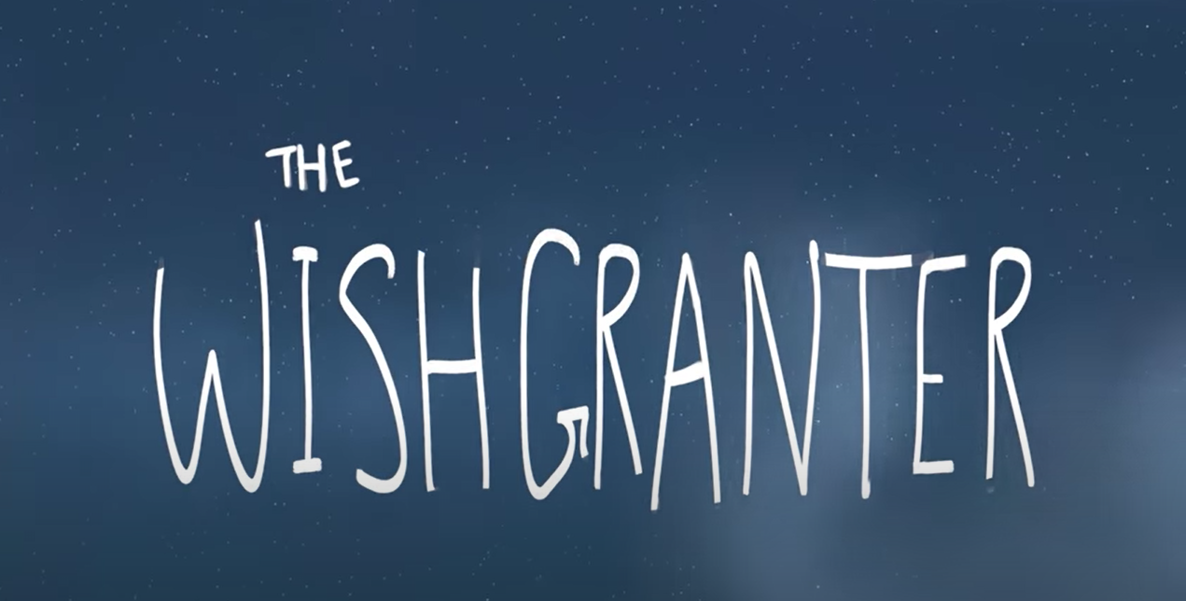
Today we are on part two of the story.
Today we are looking at part 2 0.38 seconds – 1 minute – Wish granted.
Your writing targets today are:
To write about feeling, but try and show feelings not just tell the reader
To use a simile

Lets start with target 1
We don’t want to tell the reader someone is happy/ sad, grumpy/ tired … we want to show the reader how the character feels by giving them some clues and using the best adjectives and verbs to suit the mood. At this part of the story the Wishgranter clearly shows us how he is feeling by what he is doing and how he looks. Make a note of some words you might use to explain to the reader what the Wishgranter is doing.
Slouched
Slumped

Target 2
Similes are used to give a comparison and it helps the reader visualise what is happening.
Here are some examples
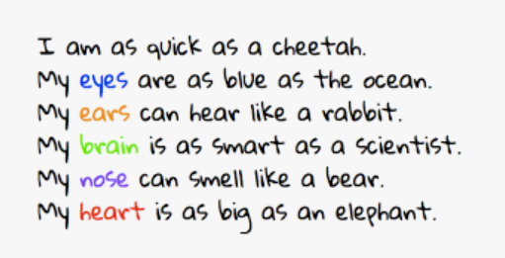
To write a simile you have to use like or as. Think about the Wishgranter, can you write some similes? Use the sentences above to help
The Wishgranter’s eyes are _______________________________
The Wishgranter’s ears _________________________________________
The Wishgranters heart ________________________________________

Writing time
Here is a WAGOLL for this part of the story – can you see my how I have shown feelings and where I have used a simile?
The money sensor glowed green on the high-tech computer as the Wishgranter lifelessly reached towards the button. He pressed the button without raising his head – not another predictable wish! Like a flurry of fireflies, the wish rose through the tubes and was released.

Now you have a try remember you need to show feelings and use a simile. It only needs to be a few sentences long, but make them interesting!

__________________________________________________________________________________________________________________________________________________________________________________________________________________________________________________________________________________________________________________________________________________________________________________________________________________________________________________________________________________________________________________________________________________________________________________________________________________________________________________________________________________________________________________________________________________________________________________________________________________________________________________________________________________________________________________________________________________________________________________________________________________________________________________________________________________________________________

