Today we are on part three of the story.
Today we are looking at part 3 1:01 seconds – 1:22 minute – Feeling hopeful.
Your writing targets today are:
To use precise verbs
To use the conjunction but

Lets start with target 1
In this part of the story the characters are walking. We need to consider the best vocabulary to use to be precise and show how these characters are really moving. There are lots of synonyms for walking that we can choose from. In the box list as many synonyms for walking that you can think of, you can use a thesaurus if you would like.
Stomped
Ambled

Target 2
After and, but is one of the first conjunctions we learn about in school. It is a coordinating conjunction and helps me to add more detail to my sentences.
In which of these sentences can I add but. What could I add to the sentences where but doesn’t work?
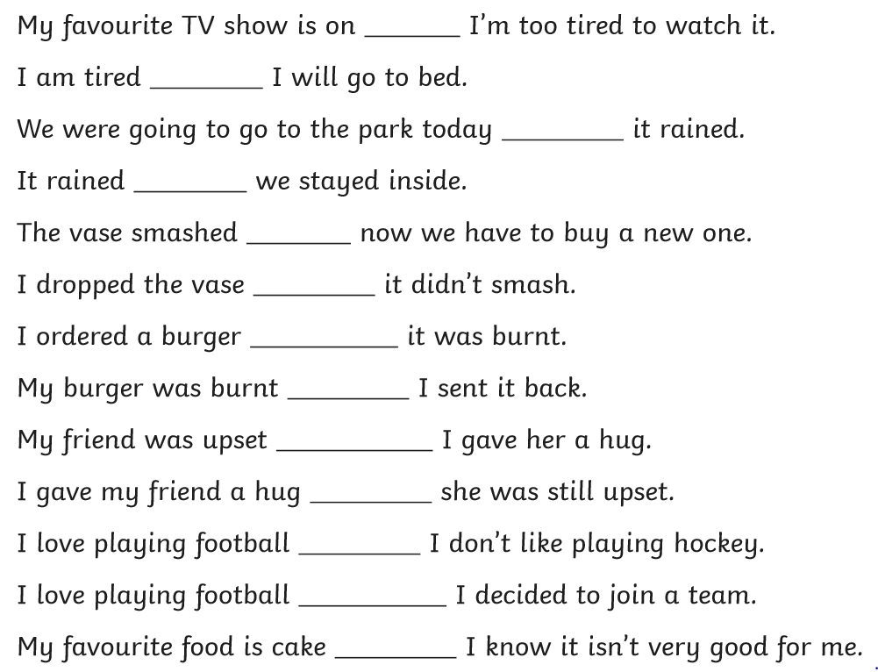

Writing time
Here is a WAGOLL for this part of the story – can you see my precise verbs for walking and my sentence with but?
Before long, more people approached the fountain to try their luck. After a long day, Malcolm trudged off the bus and drifted across the piazza. Maybe the wishing fountain could change his luck. On the other side of the square, Audrey was closing her floristry shop. It was an awful day for business, but she found a solitary coin at the bottom of her coin jar that she could make a wish on. Two young, hopeful dreamers, who both wanted to find true love, stood either side of the fountain and made a momentous wish in unison.
Now you have a try remember you need to use precise verbs and but. It only needs to be a few sentences long, but make them interesting!

__________________________________________________________________________________________________________________________________________________________________________________________________________________________________________________________________________________________________________________________________________________________________________________________________________________________________________________________________________________________________________________________________________________________________________________________________________________________________________________________________________________________________________________________________________________________________________________________________________________________________________________________________________________________________________________________________________________________________________________________________________________________________________________________________________________________________________

