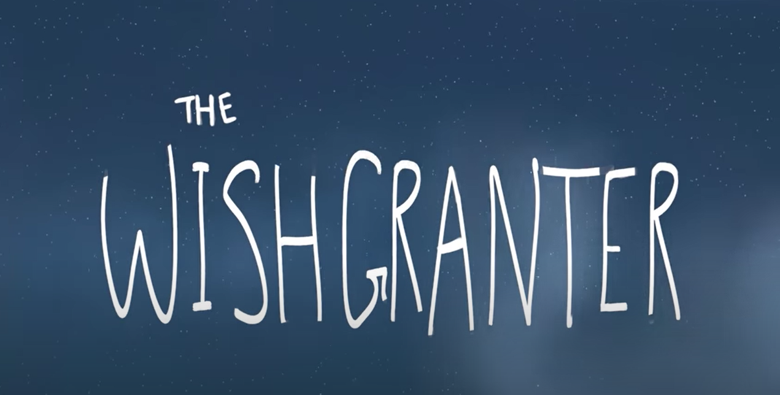

To finish the week, why not takes some time to look back over your writing from the week. Re read your paragraph from each day. Are there any spelling mistakes? Have you missed any punctuation? Could it be changed or improved? Once your happy, you could type up your story so far or write it in neat.

