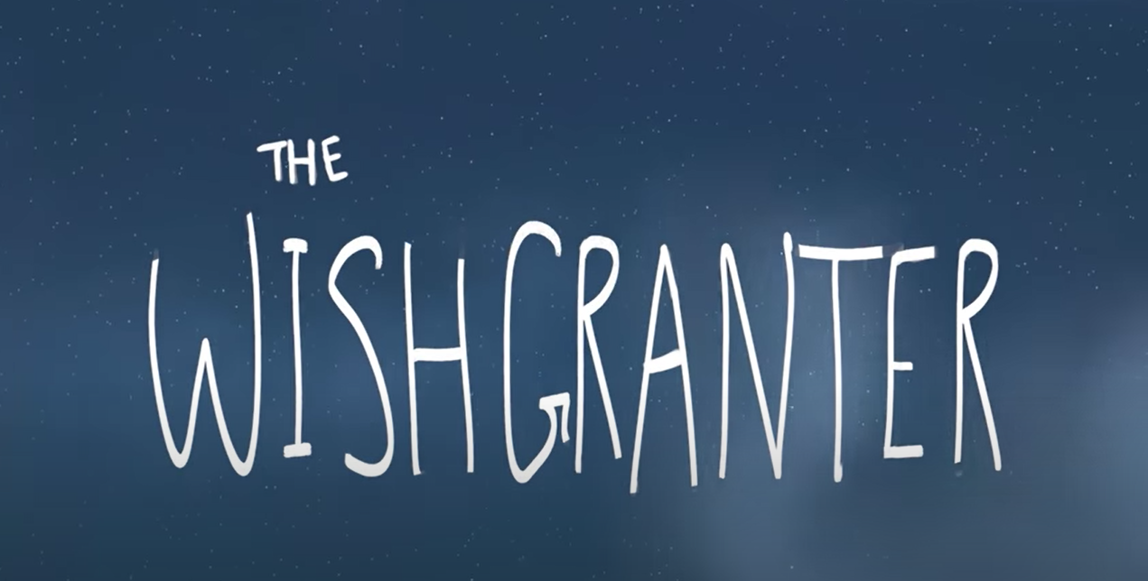
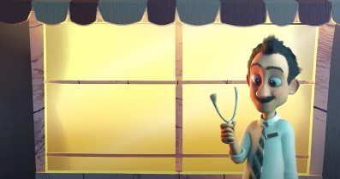
Today we are on part five of the story.
Today we are looking at part 5 1:51 – 2:17 Emergency.
Your writing targets today are:
To use alliteration
To include internal thoughts

Lets start with target 1
Alliteration is when you use the repitition of a starting letter in sentence. Using alliteration on two words can sometimes seem accidental, so trying to use it over more than two words can have a bigger impact. Can you add some more words to the table that start with the same letter?
Panic | Watched | Sneak

Target 2
Showing the the reader the characters internal thoughts can add more depth to your writing. In this story the Wishgranter is a silent character so we can’t show his personality/ feelings through his speech so using internal thoughts is a good method.
As the Wishgranter peeks out of the drain what is he thinking?

Writing time
Here is a WAGOLL for this part of the story – can you see my alliteration and use of internal voice?
With panic pulsing in his eyes, the Wishgranter pulled the emergency pack from the wall. Lifting the lid, he looked inside and considered his options. The Wishgranter climbed the ladder and looked outside. How can I fix this? He thought as he spotted Malcolm and Audrey walking in opposite directions. He snuck throught the deserted streets towards Audrey’s flower shop and hid underneath.
Now you have a try remember you need alliteration and internal thoughts. It only needs to be a few sentences long, but make them interesting!

__________________________________________________________________________________________________________________________________________________________________________________________________________________________________________________________________________________________________________________________________________________________________________________________________________________________________________________________________________________________________________________________________________________________________________________________________________________________________________________________________________________________________________________________________________________________________________________________________________________________________________________________________________________________________________________________________________________________________________________________________________________________________________________________________________________________________________

