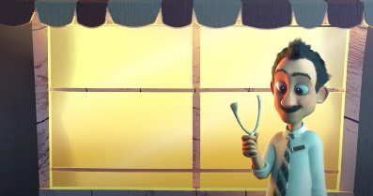
Today we are on part six of the story.
Today we are looking at part 6 2:18 – 2:48 Plan 1.
Your writing targets today are:
To use brackets
To use personification

Lets start with target 1
Using brackets alow us to add some additional information to our writing that isn’t vital to the story – we can call this parenthesis
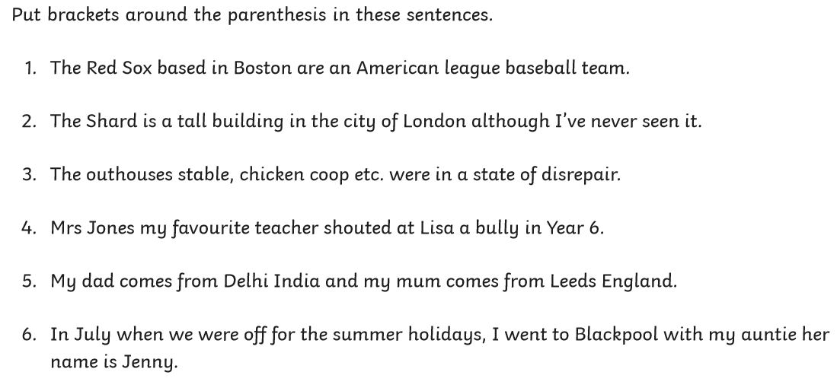
Can you add some parentheseis to this sentence about the story. What extra information can we give about the dandelion?
The Wishgranter released the dandelions (________________________________________________________).
Target 2
Personification is when we give human characteristics to something non human. Here are some examples of personification
- Lightning danced across the sky.
- The wind howled in the night.
- The car complained as the key was roughly turned in its ignition.
- Rita heard the last piece of pie calling her name.
- My alarm clock yells at me to get out of bed every morning.

The verbs the writer has chosen suggest a human action.
A part of the story where we could use personification is when the dandelion are falling. Can you think of a way to personify the way they move?
The dandelion …

Writing time
Here is a WAGOLL for this part of the story – can you see my brackets and personification?
I need to put this right, thought the Wishgranter as he launched his first tool into the flowers. Three dandelions (the ones you blow) were released. Before long, Audrey spots the new flowers and drops them in to the bin. Feeling disappointed, the Wishgranter tries again. He lauches his next steel ball. It knocks Malcolm on the head and releases yet more dandelions. The dandelions dance through the air, but Malcolm seems oblivious to them. One of the stems lands infront of the waiter, he blows and makes his wish. Instantly more money appears infront of him. This isn’t what the Wishgranter wanted.

Now you have a try remember you need use brackets and personification. It only needs to be a few sentences long, but make them interesting!

__________________________________________________________________________________________________________________________________________________________________________________________________________________________________________________________________________________________________________________________________________________________________________________________________________________________________________________________________________________________________________________________________________________________________________________________________________________________________________________________________________________________________________________________________________________________________________________________________________________________________________________________________________________________________________________________________________________________________________________________________________________________________________________________________________________________________________

