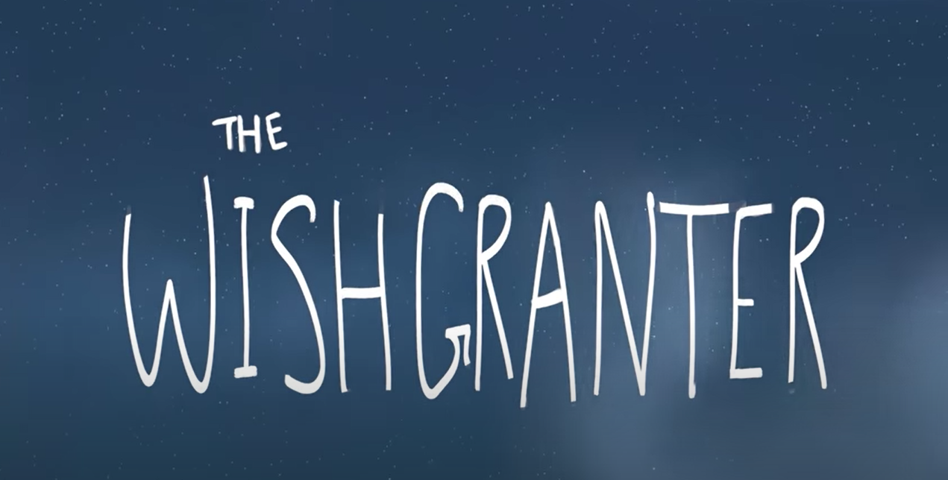

Now it is time for you to take control. Can you write the rest of the story? You have the rest of the week to finish it. Can you try and include some of the features we have looked at in the last two weeks: lists, relative clause, similes, feeling, short sentences, personification, brackets, alliteration …

If you finish before Friday, don’t forget to check your work for spellings and punctuation.

