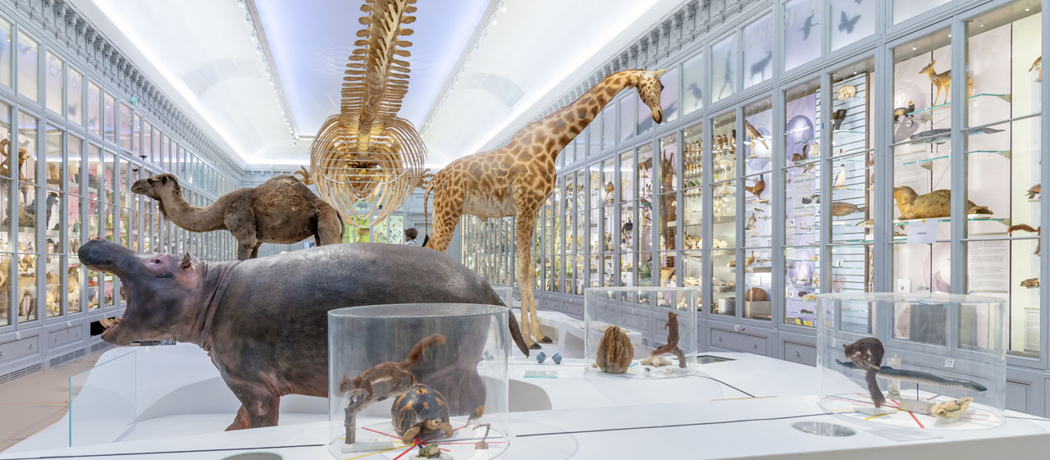

Create your own museum
For the next couple of weeks we are going to be looking at museums. We will be learning about how to write description for the artefacts considering different audiences.

Lesson 1
Todays is a short lesson of exploring and gathering ready for lessons later in the week.
Take a look here https://www.prm.ox.ac.uk/ where you can wander around on a virtual tour if you like. The museum is jam-packed with cabinet upon bulging cabinet, drawers stuffed to bursting with layers and layers of fascinating items...
Once you’ve got a bit of a feel for the place, navigate your way to the lower floor collections: Online Collections > Ethnography and archaeology > Selected Lower Gallery objects (http://web.prm.ox.ac.uk/LGweb/index.htm).

Browse whatever category takes your fancy. As you explore the site, you might like to bookmark (add to your browser favourites) any objects that interest you in particular and ones that have especially full and helpful descriptions/explanations.
Find at least three artefacts which have full and helpful descriptions that you can use later in the week.

