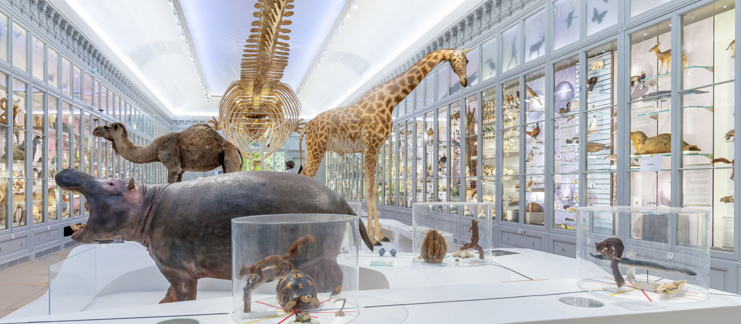

Create your own museum
For the next couple of weeks we are going to be looking at museums. We will be learning about how to write description for the artefacts considering different audiences.

Lesson 2
Activity 1
Find definitions for the words: archaeology, anthropology, ethnography.

Activity 2
Look at the three artefacts you selected yesterday and their descriptions. You need to look at these descriptions in detail and identify what makes them successful.
On the computer or on paper find a way to highlight or label the description. Or you could just write some notes.
You should think about the type of information they have included, how they have used descriptive vocabulary and any techniques they may have used. Below there are two examples of what you need to do.

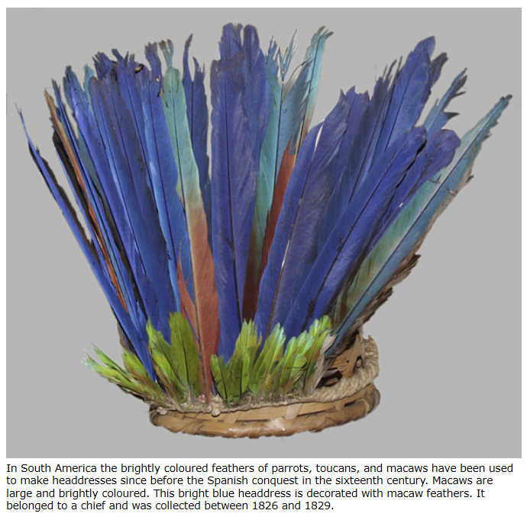
Key dates
Description of object
Who it belonged to
Use of adjectives to describe the bird
Where it is from
Dates of when it is from
List of birds whose feather’s were used

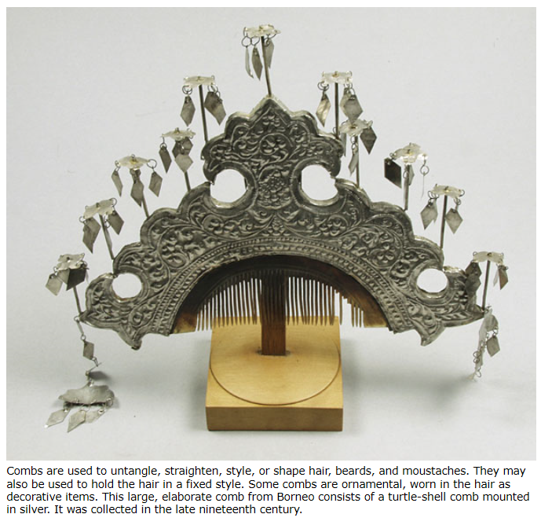
Alternative purpose
Where it is from
Materials it is made from
Use of adjectives to describe
List of uses

