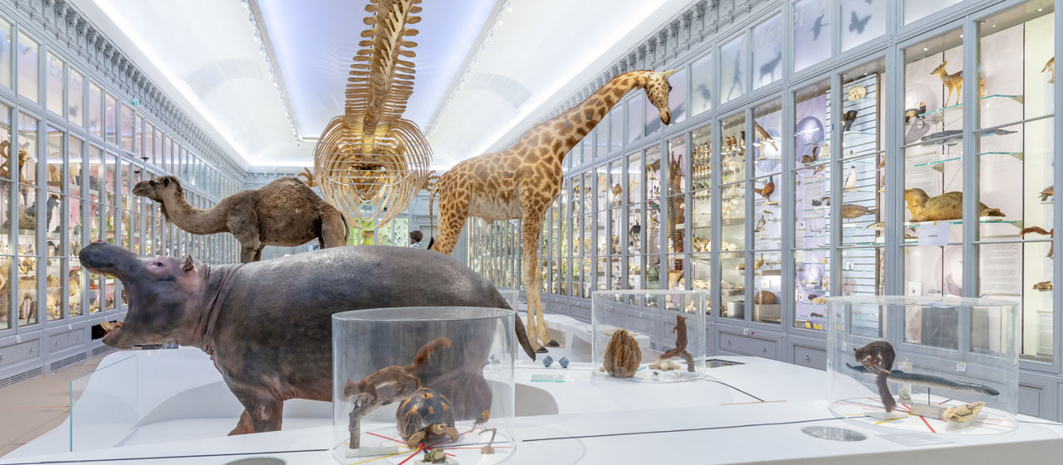

Create your own museum
For the next couple of weeks we are going to be looking at museums. We will be learning about how to write description for the artefacts considering different audiences.

Lesson 3
Using what you learnt yesterday from studying the descriptions of different artefacts in the museum, today you are going to try and write you own description of a couple of objects.
I have selected some interesting artefacts from the website, I may have selected one that you have chosen, but you can chose to write your own description or skip that one. With each artefact I have given you some key facts to include in your sentences. You should aim for you description to be about 3 sentences long and include precise language and appropriate adjectives. For example you want to avoid language such as big, small, bits, parts, old … use a thesaurus or thesaurus online to help. I have also added a colour thesaurus to the documents for this week on the website to help you descriptions.
Remember the descriptions don’t just describe how the artefact looks but when it was used, what is was used for, who used it, where it is from …

Can you use any language from the table?
Verb ‘to be’ | Optional adverbs | Verbs linked to – making, getting, valuing, believing
Is  Are  Was  Were  To be | Often  Probably  Generally  Sometimes  Rarely  Most likely  Certainly  Regularly  Usually  Typically  Still  Once | Made  Crafted  Wrought  Spun  Created  Polished  Edged  Fringed  engraved | Formed  Inlaid  Sewn  Carved  Joined  Cast  Assembled  Used  attached | Brought  Sold  Bought  Taken  Seen  Found  Purchased  Collected  Discovered  Unearthed  Excavated  Acquired | Prized  Treasured  Revered  worshipped | Considered  Thought  Believed  Associated  Supposed  Known  Assumed
Modal verbs
Would
Can
May

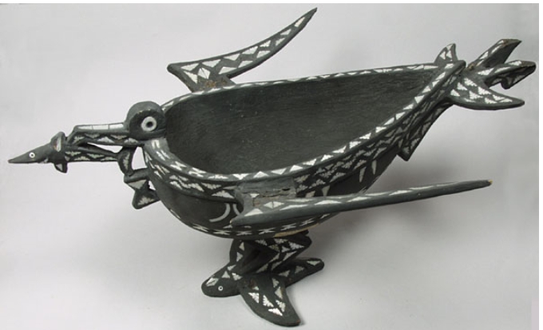
What | Where | When | Material | Use
Vessel | Solomon Islands | Before 1890 | Wooden and Haliotis shell – made in to shape of Man-o-war | Used all over the world

______________________________________________________________________________________________________________________________________________________________________________________________________________________________________________________________________________________________________________________________________________________________________________________________________

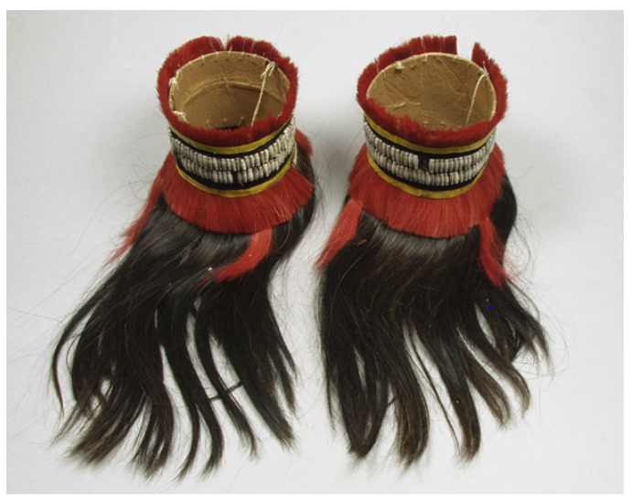
What | Where | When | Material | Use
Angami Naga armlets | India |  | cardboard,  goat's hair  coix lacryma seeds, yellow orchid stem, human hair | Body ornament

____________________________________________________________________________________________________________________________________________________________________________________________________________________________________________________________________________________________________________________________________________________________________________________________________________________________________________________________________________________

Now you could try writing your own description for an artefact of your choice.

