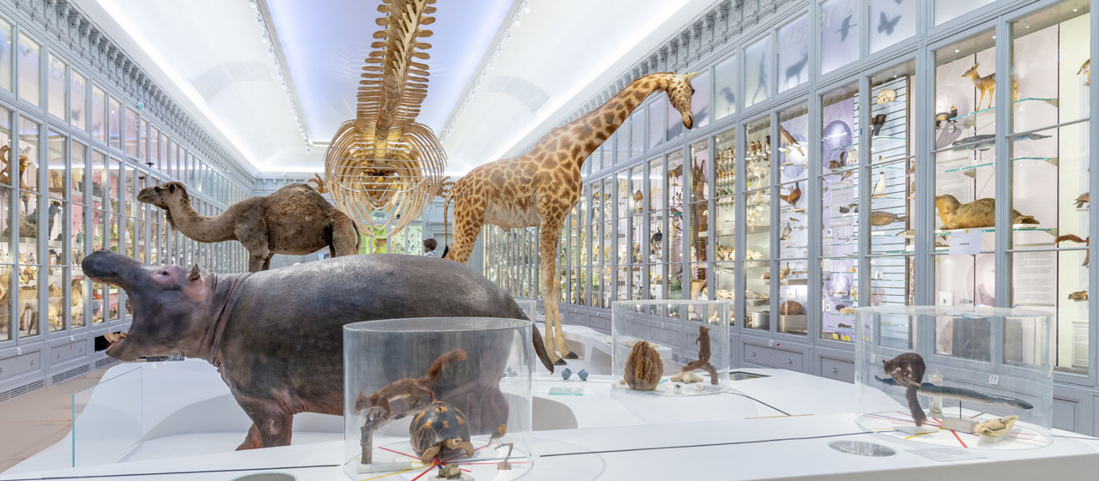

Create your own museum
For the next couple of weeks we are going to be looking at museums. We will be learning about how to write description for the artefacts considering different audiences.

Lesson 4
Now we are going to start thinking about our own museum. Today you need to have a look around your house and find 3 or 4 interesting objects that you want to put in your museum. Look for objects that are special, old, unusual, have a story … Think about what people may be interested in.
Once you have selected the objects you want to focus on. Try to photograph the objects. Think about the photographs on the museum website were presented and how they used a white background. Think about taking a photo from different angles where necessary to show all the parts.

Now you have photographed your objects, you need to start making some notes about these objects ready for your writing tasks next week. You could use a table to organise your notes like the table below, or you can do it your own way.

What it is | Where it is from | How old it is | What it is made from | Colours | What it is used for | Interesting facts

