[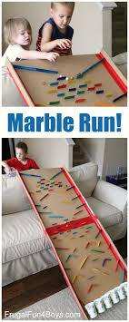](https://www.google.co.uk/url?sa=i&url=https%3A%2F%2Fwww.pinterest.com%2Fpin%2F76490893650474603%2F&psig=AOvVaw1U_vuz6Ky-SbqspnHYpg1U&ust=1593168262315000&source=images&cd=vfe&ved=0CAIQjRxqFwoTCMDMsNfknOoCFQAAAAAdAAAAABAD)[](https://www.google.co.uk/url?sa=i&url=https%3A%2F%2Fbuggyandbuddy.com%2F10-awesome-homemade-marble-runs%2F&psig=AOvVaw1U_vuz6Ky-SbqspnHYpg1U&ust=1593168262315000&source=images&cd=vfe&ved=0CAIQjRxqFwoTCMDMsNfknOoCFQAAAAAdAAAAABAJ)[](https://www.google.co.uk/url?sa=i&url=https%3A%2F%2Fbabbledabbledo.com%2Fhow-to-choose-or-make-a-marble-run-your-kids-will-love%2F&psig=AOvVaw1U_vuz6Ky-SbqspnHYpg1U&ust=1593168262315000&source=images&cd=vfe&ved=0CAIQjRxqFwoTCMDMsNfknOoCFQAAAAAdAAAAABAP)

Can you design and make your own marble run?

Use materials around your house to create a system that a marble can follow. Think about tunnels, bridges, tubes, drops … I have included a range of photos to give you some inspiration. It could be as big or small as you want.

Don’t forget – design your run first. This will give you a plan of what you want to do. If you don’t plan/design you often waste a lot of time working out what to do. You can always change and adapt your plan as you go.